

**GERMAN MALAYSIAN INSTITUTE**

**DATA MANAGEMENT**

**[PBL 1]**

**PREPARED BY:**

|  |  |
| --- | --- |
| **NAMES** | **GMI NO.** |
| **PUTRA DANISH NOR QAYYUM BIN NORDIN** | **EIT21070658** |
| **MUHAMMAD ARIF DANIAL BIN SUHAIMI** | **EIT21070233** |

|  |  |  |
| --- | --- | --- |
| **MARKS** | | |
| INTRODUCTION |  | /4 |
| PROBLEM STATEMENT |  | /4 |
| METHODOLOGY |  | /10 |
| DISCUSSION |  | /10 |
| CONCLUSION |  | /4 |
| **TOTAL** |  | **/20** |

|  |  |
| --- | --- |
| **TTO NAME** | **Ms Zawani** |
| **COMMENT** |  |

INTRODUCTION

In this era, most people use online services as it much easier than physical services. For example, people nowadays regularly buy things using online system such as buying foods, outfits and games. In this assignment, students are required to design an online system to sell online games. Specifically, it calls an e-sport where people can buy games instantly from the internet without needing to queue up at arcade. This system can make people lives be much easier as they don’t have to spend more time buying games at arcade. The website that had been designed is purposely use to reserve variety of online games. People don’t have to scramble to buy online games anymore after this website had launched to public. In this website, buyer also can choose the genre that they want to play. User just need to log in to the system and look for their desire games. After customer has bought the games, they will get a confirmation that the games had successfully received. Then, customer just need to show the invoice confirmation to the worker at the arcade.

Problem Statement

During the preparation of this assignment, lots of problem must be encountered because not all assignments can be completed so easily. For this assignment, bunch of tries and error that need to be endure to make sure that this games online system can work perfectly. As example, when using cinema website several pop ups will show up and it can be really annoying for certain customer. So, this website’s security needs to be strengthened so that a lot of people will use it. Besides that, this system needs to be upgrade from the current way which is walk into the arcade and it would totally waste customer’s time.

METHODOLOGY

1. Site Map

HOMEPAGE

INVOICE

GAMES PAGE

PERSONAL DATA

DESCRIPTION

GAMES DATA

GAMES BUY

VIDEO TRAILER

1. Multimedia Storyboard

Game Logo

Game #1

Game #2

Game #3

Game #4

Game #5

Game #6

Game #10

Game #9

Game #8

Game #7

This is an example on how our page looks like, one game page that had been choosed:

1. Game Page
2. Movie Page

Staff

Gallery

Home

Game Title

GAME PAGE

Developer

Synopsis

Game Data

This is the example on hoe the trailer page look like in our website.

1. Game Trailer

Game Trailer

Game Photo

Game Photo

This is an example on how the game page looks like in our website. Users can easily access to this page and it’s a user-friendly page.

1. Invoice Page

|  |  |
| --- | --- |
| Full Name |  |
| Phone Number |  |
| Email |  |
| Address |  |
| Game password |  |
| Total Price |  |

This is an invoice page for the game that had been bought, in this invoice page it would shows all the personal data buyer.

1. Webpage Print Screen

Database Game

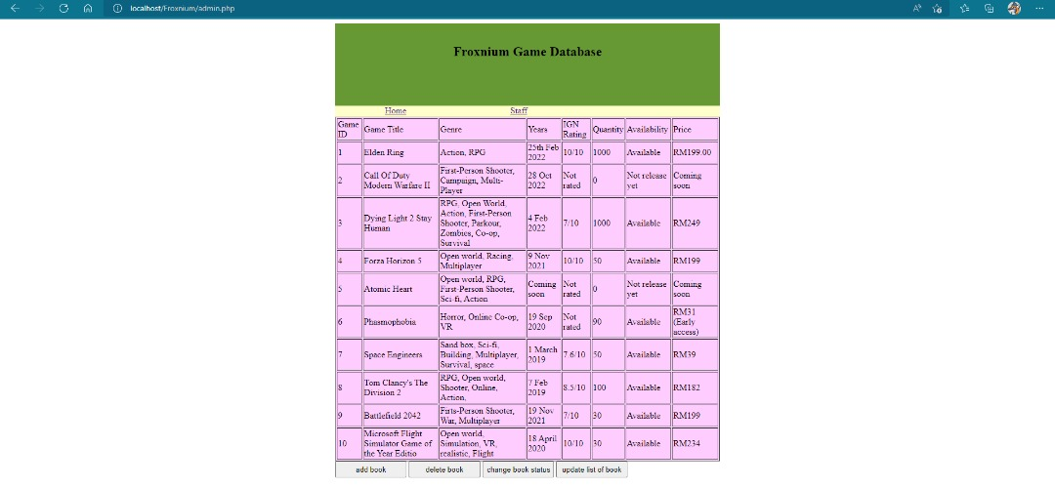

Home Page

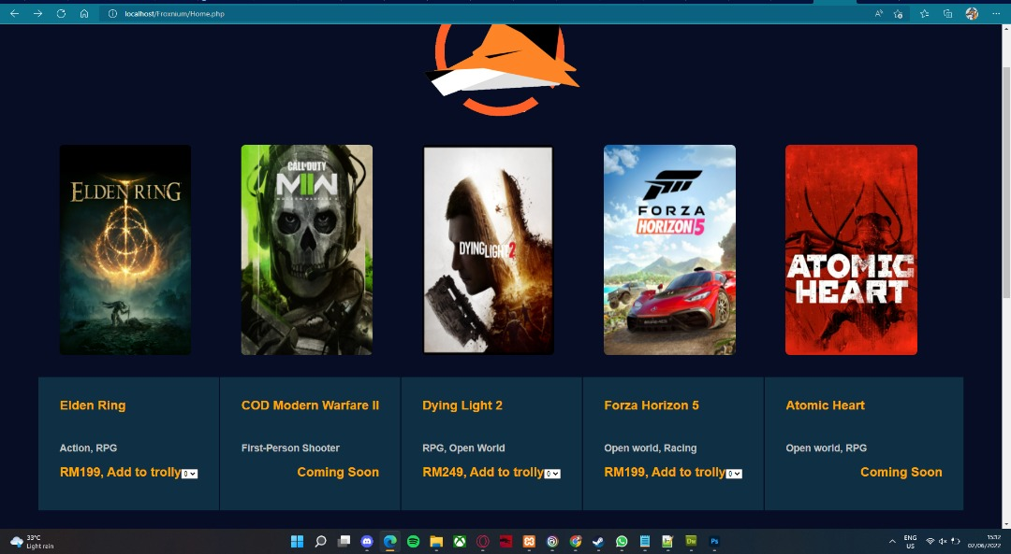

Game Page

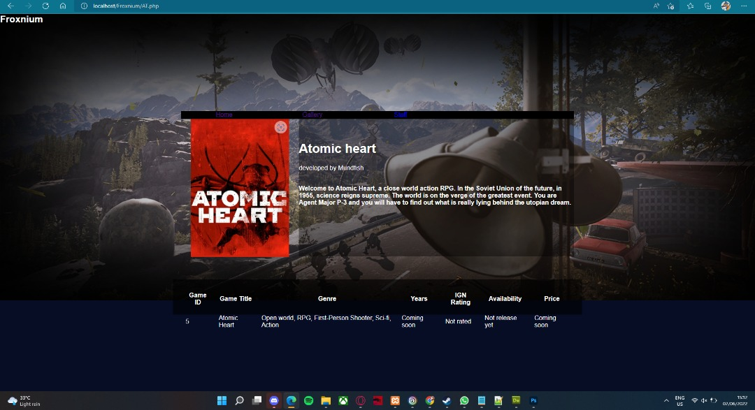

Trailer Page 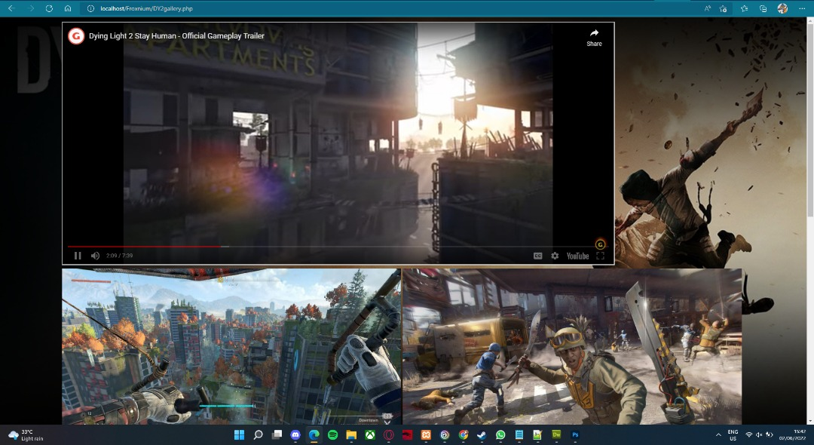

Invoice

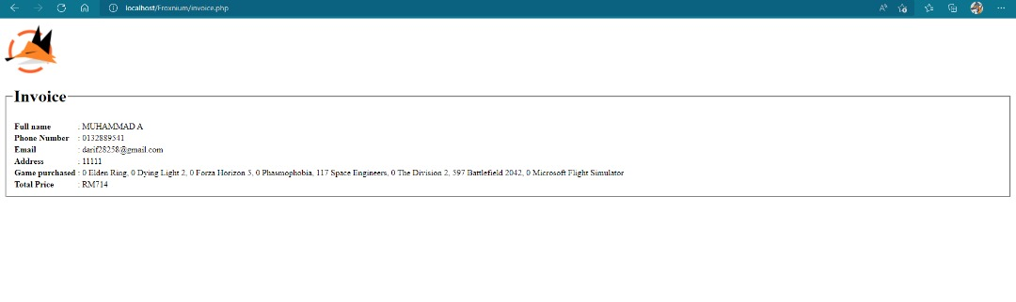

Games

Discussion:

1)Homepage

First, for the Homepage site, we just use HTML coding for the function and use CSS coding for the style. Below is the output for the Homepage site;



Figure 1.1

CSS coding was use for the background image of website and for the table to arrange the image for the 10 games that show as Figure 1. The CSS coding is;

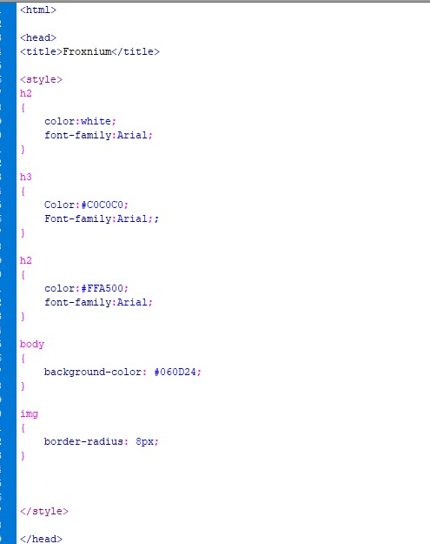

Figure 1.2

The CSS coding that shown in Figure 2 is use to design only in the Homepage site because the code was in the same place for the site code place. The code location was in “<head>” attribute and after “<title>” attribute.

For the function of the HTML was use the button type to the image to make the user click to the image when they choosing and then bring the page to the game page. The button also was hyperlink to the game using “<a href>” attribute to make sure the button connects to the game page. For the image of each button was using “<img src>” attribute and place the image to the same file place of the coding. The HTML function code is below;

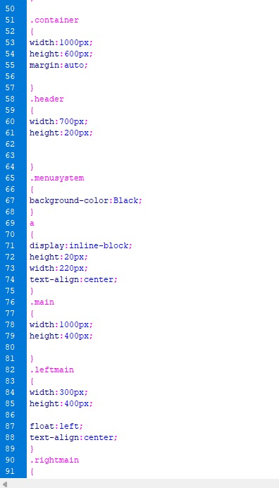

Figure 1.3

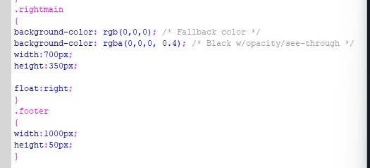

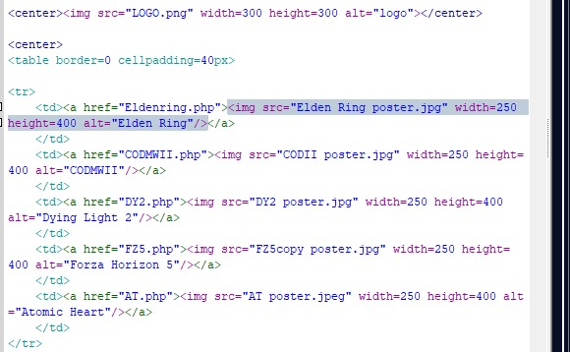

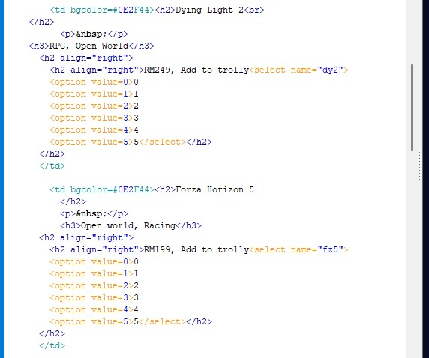

2)Games page

Next is the game page. This page still using the HTML function code and CSS code for the design. Using form attribute to with action to invoice page and the method is post and the describtion of the games.



Figure 2.0.0 form attribute code

The output of game page was like below;

Table Games for Game Page coding:



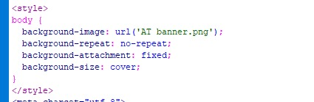

For HTML form, there is many various inputs like hyperlink. For the Time input, hyperlink was used for this page to make the user choose only one time for the game. The code of the hyperlink for time select is;

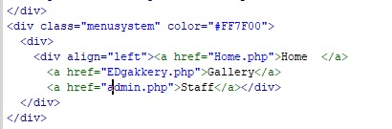

Figure 2.4 Hyperlink input code

3)Trailer Page



For this trailer page, it is just a simple coding that insert the video and the photo into the website:

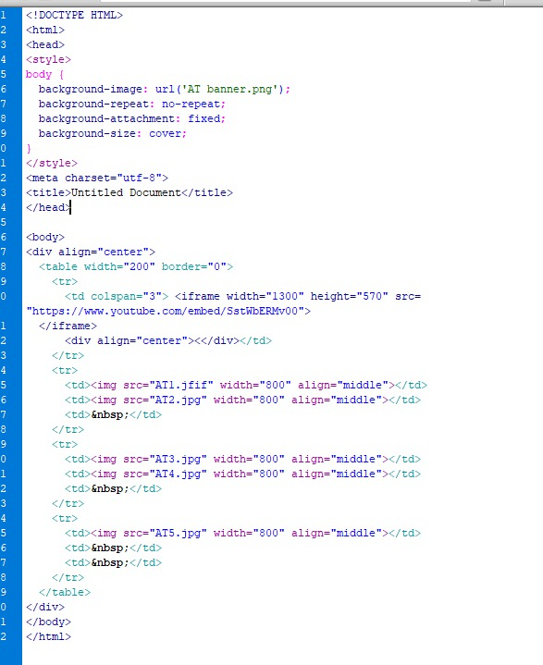

4)Invoice Page

For the last page that is the invoice page that function to collect all data that user input in the form in game page. The output of the invoice is;



Figure 3.1 Invoice output

For the coding was using CSS for background design, HTML for the table and php to call the data that input in the form at game page. Because of the post method at the movie page form, the data input can be call by declare the name of each of the input type. For the calculator that calculate the total price shown in the code below;

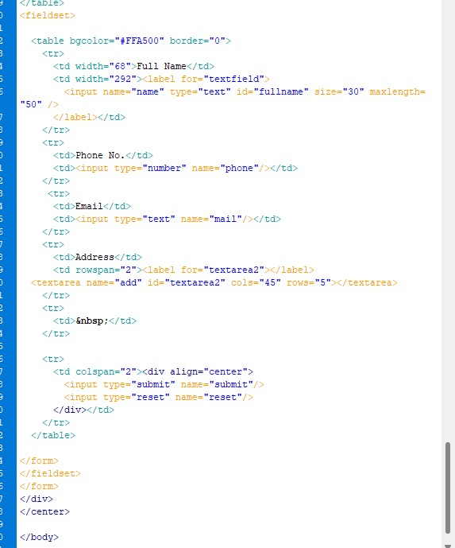

Conclusion:

In conclusion, an online service to buy tickets online needs to be practiced by most people nowadays. This e-sport is really useful because it can help ease up people’s work these days. However, various problems would still come up in the first place such as website jammed when a lot of people use it. This website can help people saving up some times because people do not need to queue up anymore to buy online games. Computing programs such as PHP and HTML are included in this assignment to design the website that helps a lot of people to buy online games. There’re still a lot of problems that arise while using the programs, as example various bugs and errors were found when the website was to be developed. Nevertheless, we still managed to design the website and launched it to public for people to use it.